CMSD TRANSPORTATION  SCHOOL BUS ENROLLMENT  2023-2024  May 30 – july 10, 2023 | - 
  ATTENTION PARENTS & GUARDIANS  To be more efficient with our transportation services, we are requiring parents to OPT-IN for school bus transportation for the 2023-2024 school year.  - This is for all Cleveland residents who are eligible for transportation.  - Families will have the opportunity to OPT-IN for AM transportation, PM transportation, or ROUNDTRIP.  - To register for school bus transportation, use the link to the right to complete the form online before the deadline.  - We know circumstances change throughout the year. Parents will always have the opportunity to change their transportation request after July 10 by contacting 216-838-4BUS (4287). | 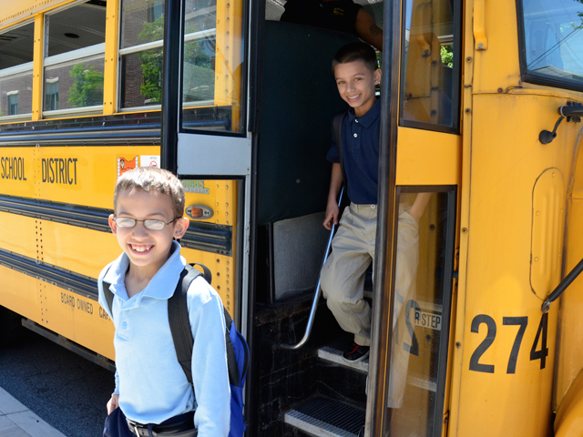  OPT-IN LINK:  https://app.smartsheet.com/b/form/2256f6c4ecb442bc998fa68626293f4e  Opt-In Enrollment Period  May 30 –  July 10, 2023

